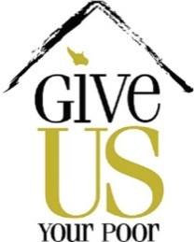

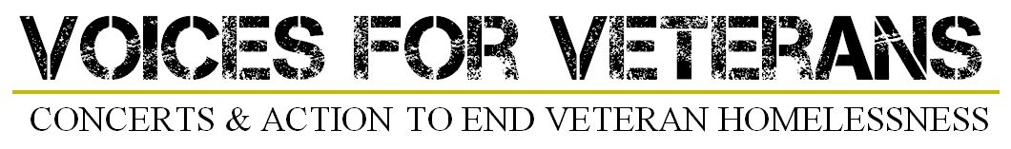

Key Partners Media & Social Media Action Kit

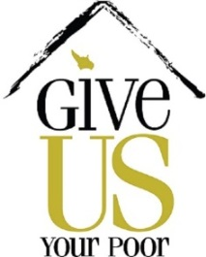

Dear Key Partner,

Thank you for partnering with Give US Your Poor and standing with our mission to end veteran homelessness. Please consider sharing with your network and social media following information regarding this partnership and what we are accomplishing together. Included in this partner toolkit are sample Facebook, Twitter, and blog posts for our Voices for Veterans benefit concert and #WithTheseHands photo campaign. Both of these initiatives are directed toward helping homeless veterans living in the United States.
Voices for Veterans (VfV) is a national initiative using the power of music to permanently house homeless veterans by engaging celebrity musicians to raise awareness, money for targeted programs, and volunteerism. The first Voices for Veterans concert, in what we hope will become a series of events, is kicking off in St. Louis on December 6th with performances by Smokey Robinson and Mario Frangoulis at the Peabody Opera House. The official website for information and tickets is www.VfVconcerts.org.
“With These Hands” is a photo campaign inspired by the final verse of Bruce Springsteen's song, "My City of Ruins." It is designed to engage US all to be part of the solution to homelessness… Uniting those experiencing homelessness and those with housing, veterans and civilians alike by showing your support to end veteran homelessness.
For questions and assistance please contact Andrea Locke, Capacity Building Coordinator at andrea.locke@familyhomelessness.org or 781-373-7010.

Thank you,
John McGah

Voices for Veterans

Tips
- Tag Give US Your Poor by typing the “@” symbol and then GiveUSYourPoor
- Use #VoicesforVeterans & #WithTheseHands
- Capitalize Vs in website, ex. www.VfVconcerts.org
- Include pictures of Smokey Robinson and Mario Frangoulis
  - Publicity photos included below
- All posts need to link to: http://www.ticketmaster.com/event/06004F577A10121E?artistid=735991&majorcatid=10001&minorcatid=202&tm_link=tm_changeloc_go
Sample Twitter Posts

- Get in the holiday spirit, y’all! @smokey_robinson & @MarioFrangoulis play new holiday hits & fave classics 12/6 @ThePeabodyOperaHouse #VfV
- @smokey_robinson & @MarioFrangoulis in St. Louis on 12/6/15 to help end veteran homelessness. Learn more at www.VfVconcerts.org
- Buy your tix today to help end veteran homelessness in MO! #VfV concert with @smokey_robinson & @MarioFrangoulis www.VfVconcerts.org
- Who wants to see 2 musical greats & help a worthy cause? www.VfVconcerts.org @smokey_robinson @MarioFrangoulis @ThePeabodyOperaHouse
- Got tix? Be a change-maker! Visit www.VfVconcerts.org @smokey_robinson @MarioFrangoulis #STL
- We hear #STL is beautiful in December . . . www.VfVconcerts.org @smokey_robinson @MarioFrangoulis
- No plans 12/6/15? Here’s an idea: www.VfVconcerts.org @smokey_robinson @MarioFrangoulis
- Wow! Big thanks to @AmerenMissouri for their sponsorship of Voices for Veterans!
- @Boeing and @AmerenMissouri present Voices for Veterans to house veterans in Missouri!

Sample Facebook Posts
- Our partner @GiveUSYourPoor’s latest initiative, Voices for Veterans, is coming to #STL to help end veteran homelessness in Missouri. Buy your tickets at Ticketmaster.com/VfV and we’ll see you at the show on December 6, 2015. Busy that night, but still want to help? Your donations are greatly appreciated! www.VfVconcerts.org
- Come see Smokey Robinson & Mario Frangoulis in concert on December 6, 2015! Proceeds to help benefit veterans experiencing homelessness in Missouri. Buy tickets at Ticketmaster.com/VfV or donate today! www.VfVconcerts.org
- Get in the holiday spirit with Smokey Robinson and Mario Frangoulis on December 6, 2015!
- Join international recording artist Mario Frangoulis​ and Motown super star Smokey Robinson as they team up December 6 in St. Louis at Peabody Opera House for Voices for Veterans. Tickets are on sale now at Ticketmaster.com/VfV https://www.youtube.com/watch?v=VW1W15F1kbY.
- Thank you @AmerenMissouri for your sponsorship of @VoicesforVeterans with @Smokey_Robinson & @MarioFrangoulis. #EndVetHomelessness #Missouri
- Thank you @Boeing for your sponsorship of @VoicesforVeterans with @Smokey_Robinson & @MarioFrangoulis. #EndVetHomelessness #Missouri

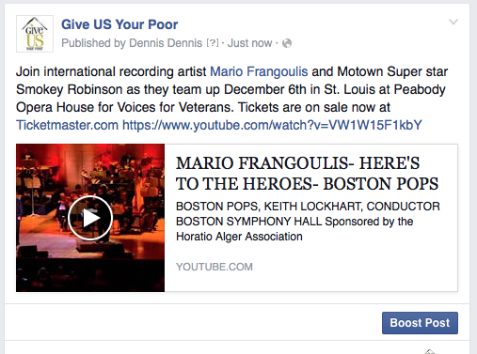
Radio PSA Read
- MOTOWN SUPERSTAR SMOKEY ROBINSON AND INTERNATIONAL RECORDING ARTIST MARIO FRANGOULIS TEAM UP DECEMBER 6TH AT PEABODY OPERA HOUSE TO RAISE FUNDS TO HOUSE HOMELESS VETERANS IN MISSOURI. TICKETS ARE ON SALE NOW FOR THE MEGA EVENT, VOICES FOR VETERANS, AT TICKETMASTER DOT COM.
VIP Experience
- Your ticket includes a premier seat and private reception before the show with show producers, community leaders, and other surprises. Support our efforts to end homelessness among our veterans by purchasing a once-in-a-lifetime opportunity to meet and mingle with the stars. VIP ticket holders will also have the opportunity for a private photo with the performers.

Artist Bios
SMOKEY ROBINSON
Bob Dylan once said that Smokey Robinson (www.smokeyrobinson.com) is “America’s greatest living poet.” During the course of his 50-year career in music, Smokey has accumulated more than 4,000 songs to his credit, while he continues to thrill sold-out audiences worldwide with his high tenor voice, impeccable timing, and profound sense of lyric.
MARIO FRANGOULIS
Mario Frangoulis (www.mariofrangoulis.com) is an internationally acclaimed tenor known for his refined vocal interpretations and ability to sing in over 5 languages. From playing Marius in Les Misérables (cast by Sir Cameron Mackintosh) and Raoul in Phantom of the Opera (cast by Sir Andrew Lloyd Webber), to performing with The Boston Pops, and artists such as Justin Hayward, Vanessa Williams, Vittorio Grigolo, and Stephan Moccio. Mario has topped the Billboard charts and sold over 1 million albums worldwide. CNN.com describes Mario as “pure sound, all voice.”

Social Media Art
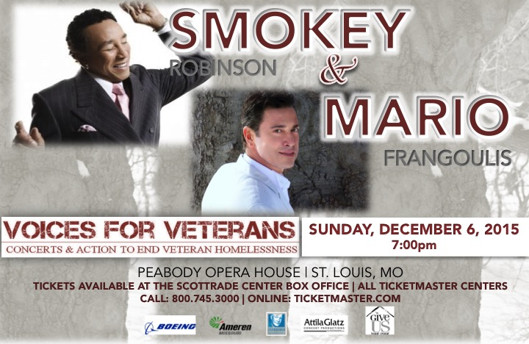

Press Release

“VOICES FOR VETERANS”
A CONCERT WITH MOTOWN ICON SMOKEY ROBINSON &
INTERNATIONAL RECORDING ARTIST MARIO FRANGOULIS
SUNDAY, DECEMBER 6TH AT 7PM FOR ONE-NIGHT ONLY!

MEDIA CONTACTS: Dennis Gorg: 314-367-3146 dennis@imsevents.com
Andrea Locke: (781) 373-7010 andrea.locke@familyhomelessness.org

(St. Louis, MO – October 29, 2015) Sunday, December 6, 2015 at 7:00PM at the Peabody Opera House in St. Louis, the stage will be electric with the one-and-only Motown icon Smokey Robinson and “best male classical crossover artist,” Mario Frangoulis will share their talent in support of putting an end to veteran homelessness. The Voices for Veterans St. Louis concert is made possible with the generous support of Boeing Defense and Ameren Missouri, and is presented by Give US Your Poor, Eisenhower Fellows of St. Louis and Attila Glatz Concert Productions.

“Boeing is dedicated to supporting the men and women of the military and the veterans who have sacrificed so much towards protecting our freedom,” said Megan Davies, Director of Boeing Defense, Space and Security’s Global Corporate Citizenship organization. “That some of our neighbors in Missouri have sacrificed so much in their service and still are without the basics of a home for themselves and their family is something we need to help rectify.”

On any given night, there are 49,933 homeless veterans on the streets of America. No man or woman who has served in the armed forces should be without a home. This is why Give US Your Poor, the national campaign to end homelessness created Voices for Veterans (www.VfVconcerts.org) — a project using the power of music to convene, inspire, and remind us of the sacrifice others have made for us so that we can be safe and free. Voices for Veterans holds concerts to raise money, awareness, and inspire volunteerism to permanently house veterans and provide needed services to support their ongoing quality of life when they return home.

The performance with Smokey Robinson and Mario Frangoulis will be a true feast for the heart and ears with songs sung in multiple languages, combined with the joyful and inspiring “Motown Sound” – the perfect way to kick off the season! St. Louis is in for one of the most unique and inspirational musical experiences to hit the “Gateway to the West!”

Bob Dylan once said that Smokey Robinson (www.smokeyrobinson.com) is “America’s greatest living poet.” During the course of his 50-year career in music, Smokey has accumulated more than 4,000 songs to his credit, while he continues to thrill sold-out audiences worldwide with his high tenor voice, impeccable timing, and profound sense of lyric.

Mario Frangoulis (www.mariofrangoulis.com) is an internationally acclaimed tenor best known for his refined vocal interpretations and ability to sing in over 5 languages. From playing Marius in Les Misérables (cast by Sir Cameron Mackintosh) and Raoul in Phantom of the Opera (cast by Sir Andrew Lloyd Webber), to performing with The Boston Pops, and artists such as Justin Hayward, Vanessa Williams, Vittorio Grigolo, and Stephan Moccio. Mario has topped the Billboard charts, selling millions of albums worldwide. CNN describes Mario as “pure sound, all voice.”
-- Continued --
Both artists have a long track record of contributing their time and talent to important causes that support the right of every single human being to live with dignity. Smokey Robinson through his groundbreaking music that has touched millions of people from all walks of life, all races and ethnicities, all over the world; and Mario Frangoulis for his undying commitment to educational support for high-risk, high-potential children.
Homelessness is about disconnection. Music is about connection. The artists and Voices for Veterans team along with our sponsors and presenters invite everyone to join in for this important celebration of compassion, love, and patriotism – honoring those who have honored us with their sacrifice. St. Louis, we are waiting for you! Proceeds will support housing homeless veterans in Missouri through Veterans Matter, Operation Homefront, Zero: 2016, and a Missouri Veterans Move-In Fund.
For tickets, ranging from $49.00 to $250.00 (VIP), and information call the Peabody Opera House at 314.499.7600 or go to www.peabodyoperahouse.com/tickets or www.ticketmaster.com. For more information go to the Voices for Veterans website at www.VfVconcerts.org.

###

#WithTheseHands

Tips
- Include a #WithTheseHands photo of your team
  - Reference examples below, feel free to be creative and use different hand positions
- Tag Give US Your Poor by typing the “@” symbol and then GiveUSYourPoor
- Use #WithTheseHands and #VoicesforVeterans

Sample Twitter Posts
- From our partner @GiveUSYourPoor: #WithTheseHands we can make a difference. #VoicesforVeterans
- It’s picture time! Snap it, tag it, & post it to join @GiveUSYourPoor in ending veteran homelessness #WithTheseHands
- #WithTheseHands I support ending veteran homelessness. @GiveUSYourPoor
- What do @BonJovi @SteveEarle & @MarioFrangoulis have in common? They show support to end veteran homelessness & you can too #WithTheseHands
- Act like a famous musician and post your #WithTheseHands pic @GiveUSYourPoor! @BonJovi @SteveEarle @MarioFrangoulis #endvethomelessness
- @BonJovi did it. @SteveEarle did it. @MarioFrangoulis did it too. Did u send @GiveUSYourPoor a #WithTheseHands photo yet? #VoicesforVeterans
- RT if you support ending veteran homelessness. Bonus points for posting your own #WithTheseHands photo @GiveUSYourPoor
Sample Facebook Posts
- Act like a famous musician and post your #WithTheseHands picture @GiveUSYourPoor! @BonJovi @SteveEarle @MarioFrangoulis #endvethomelessness
- Join our partner Give US Your Poor in their #WithTheseHands campaign to end veteran homelessness. It’s as simple as taking your picture and posting it to @GiveUSYourPoor to show your support for the cause. Join the movement that already includes Jon Bon Jovi, Steve Earle, and Mario Frangoulis! With These Hands we can make a difference. #endvethomelessness

Sample Blog Post
Have you heard of the #WithTheseHands campaign?
It’s part of a national initiative to raise awareness of the issue of veteran homelessness and the fight to end it. The campaign takes its name from the final verse of the Bruce Springsteen song, “My City of Ruins.” It engages us all to be part of the solution to ending veteran homelessness - homeless and housed, veterans and civilians alike. The campaign already includes musicians such as Jon Bon Jovi, Mario Frangoulis, and Steve Earle - not to mention all the amazing average Joe’s and Jane’s who have also submitted their photos!
The people behind the campaign are Give US Your Poor, which is a group dedicated to bringing together homeless organizations, celebrity advocates, and people like you to end homelessness. With this latest campaign, they’re using music and art to dispel myths, show support, and foster action on veteran homelessness. .”
The timing is right. In case you haven’t heard, the federal government and communities around the country are engaged in a national effort to end veteran homelessness by the end of 2015.
Nearly 50,000 veterans experience homelessness in the U.S. on a given night. That’s an improvement over previous years. Thanks to the national effort we have reduced the number of veterans who experience homelessness by 33 percent since 2010.
If you want to show your support, you can participate in the #WithTheseHands campaign. All you have to do is tweet a photo of yourself showing your hands (see the photo of Jon Bon Jovi above for an example) with the hashtag #WithTheseHands to @GiveusYourPoor.
You’ll be in good company.
Show your support to ending veteran homelessness in four easy steps:
- Snap it
- Tag it with #WithTheseHands
- Post it to @GiveUSYourPoor
- Share it with friends

Sample #WithTheseHands Photos
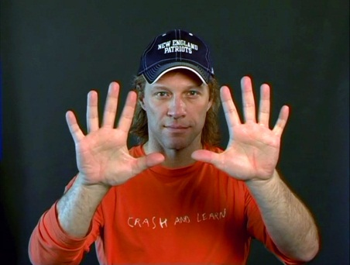
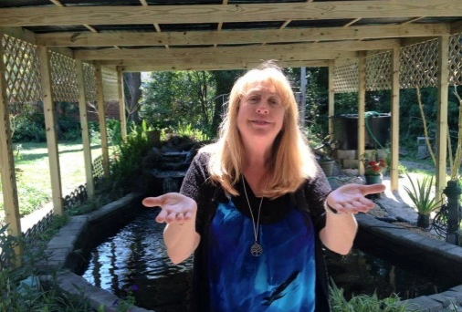

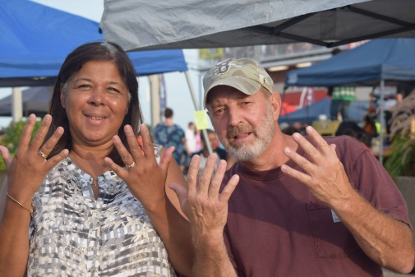
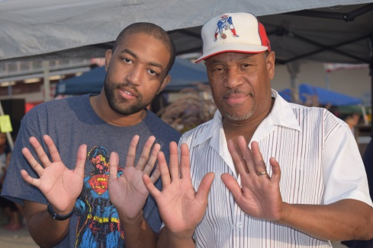

FACT SHEET

Smokey Robinson & Mario Frangoulis
Voices for Veterans

- Boeing, Ameren Missouri and Eisenhower Fellows Present
- Smokey Robinson & Mario Frangoulis: Voices for Veterans
- A Project of Give US Your Poor

What | Motown legend, Smokey Robinson is teaming up with international recording artist Mario Frangoulis to bring together a unique program of music from across the world this holiday season… to support the true heroes among us – our veterans – who have sacrificed everything to protect our freedom.  This concert event will be a true “happening” for St. Louis as two artists who are at the top of their respective genres: Smokey Robinson, legendary singer and songwriter of Motown fame, and Mario Frangoulis, 2011’s “best male classical crossover artist,” team up to blend their voices and music for Missouri’s veterans.  This event is sponsored by Boeing, Ameren Missouri, the Eisenhower Fellows, and the Horatio Alger Association of Distinguished Americans who have demonstrated their commitment to ensuring that homeless veterans are protected and supported by their own people this holiday season.
When | Sunday, December 6, 2015 ~ 7:00PM
Where | The Peabody Opera House, 1400 Market Street, St. Louis (314.499.7600)
Why | On any given night, there are 49,933 homeless veterans on the streets of America. No man or woman who has served in the armed forces should be without a home. This is why Give US Your Poor, the national campaign to end homelessness created Voices for Veterans (www.VfVconcerts.org) — a project using the power of music to convene, inspire, and remind us of the sacrifice others have made for us so that we can be safe and free. Voices for Veterans holds concerts to raise money, awareness, and inspire volunteerism to permanently house veterans and provide needed services to support their ongoing quality of life when they return home. Proceeds from the St. Louis event will stay in Missouri to support veterans through Veterans Matter, Operation Homefront, Zero: 2016, and a Missouri Veterans Move-In Fund.
How | To purchase tickets: www.peabodyoperahouse.com/tickets or Ticketmaster.com
How Much? | Tickets range from $49-$250 for VIP tickets.

